|  |  |  |  |  |
| --- | --- | --- | --- | --- |
| Residential Lease Application  Questions? Call  406-890-3505 | | | | |
| Landlord/Lessor: | River Grove Rentals, LLC | | Date of Application: | / / |
| Location of Residence: | |  | | |

|  |  |  |  |  |  |  |  |  |  |  |  |  |  |  |  |  |  |  |  |  |  |  |
| --- | --- | --- | --- | --- | --- | --- | --- | --- | --- | --- | --- | --- | --- | --- | --- | --- | --- | --- | --- | --- | --- | --- |
| **PERSONAL INFORMATION**  Name of Tenant: | | | | |  | | | | | | | | | | | | | | | | | |
| Other Names Tenant has used: | | | | | | | | | | |  | | | | | | | | | | | |
| Current Home Phone Number: | | | | | | | | | | | ( ) - | | | | | | | | | | | |
| Drivers License No. | | | | | |  | | | | | | | | | State of Issuance: | | | | | |  | |
| Total # of  Occupants: | | | |  | | | | | | |
| Occupants Names: | | | | |  | | | | | | | | | | | | | | | | | |
| (If applicable, not | | | | | | |  | | | | | | | | | | | | | | | |
| including yourself.) | | | | | | |  | | | | | | | | | | | | | | | |
|  | | | | | | |  | | | | | | | | | | | | | | | |
| **EMPLOYMENT**  Place of Employment: | | | | | | | |  | | | | | | | | | | | | | | |
| Address: | |  | | | | | | | | | | | | | | | | | | | | |
| Supervisor: | | |  | | | | | | | | | | Phone: | | | | ( ) - | | | | | |
| Your Job Title: | | | |  | | | | | | | | | | Work Hours: | | | | |  | | | | |
| Monthly Pay: | | | |  | | | | | | | | | | How long at current job? | | | | | | | |  | |
| Other sources of income: | | | | | | | | | |  | | | | | | | | | | | | |
|  | | | | | | | | | |  | | | | | | | | | | | | |
| Have you ever filed Bankruptcy? | | | | | | | | | | | | | | | | | | Yes | | | No | |
| -If yes, court and case number? | | | | | | | | | | | |  | | | | | | | | | | |
| Have you ever been convicted of, or pleaded guilty or no contest, to a felony? | | | | | | | | | | | | | | | | | | Yes | | | No | |
| -If yes, please describe. | | | | | | | | |  | | | | | | | | | | | | | |
| Are there any judgments or lawsuits against you? | | | | | | | | | | | | | | | | | | Yes | | | No | |
| -If yes, please describe. | | | | | | | | |  | | | | | | | | | | | | | |
| Bank Name: | | |  | | | | | | | | | | | | | Phone: | | | |  | | |
| References: | | | | |  | | | | | | | | | | | | | | | | | |
| Name: |  | | | | | | | | | | | | | Phone: | | ( ) - | | | | | | |
| Name: |  | | | | | | | | | | | | | Phone: | | ( ) - | | | | | | |
| Name: |  | | | | | | | | | | | | | Phone: | | ( ) - | | | | | | |

**Conditions and Information**

The completing of this application by Tenant and the acceptance of this application by Landlord creates no obligation of Landlord to approve the application, nor guarantees availability of housing. Once submitted, this application becomes property of the Landlord.

This application can be denied for a variety of reasons, including, but not limited to:

* Unsatisfactory credit report
* Unfavorable reference by a former landlord and / or employer
* Criminal history
* False statements on application
* Unverifiable information
* More qualified applicant

This application will be approved or rejected usually within five (5) days of being submitted to landlord. If applicant is denied, a written denial will be mailed to applicant at present address.

If this application is approved, Tenant must prove identity, make the security deposit, the first month’s rent (or pro-rated portion of the first month’s rent), and sign the lease before the tenancy begins.

Property Manager/Landlord complies with all Federal and State laws regarding discrimination and does not discriminate based upon age, sex, race, creed, familial or marital status, religion, national origin, or other prohibited classifications.

**River Grove Rentals, LLC**

**371 3rd Ave East N**

**Columbia Falls, MT 59912**

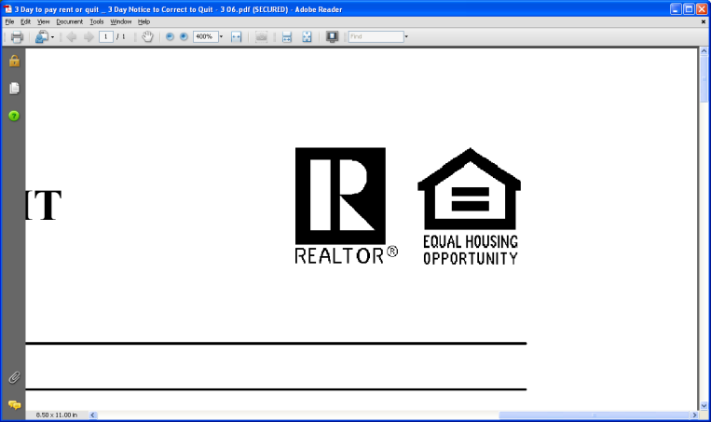

Do you smoke?  Yes  No Note: This provision does not imply that smoking is allowed.

How long do you intend to reside here? ______________________________________________

**RADON GAS DISCLOSURE. Radon is a naturally occurring radioactive gas that, when it has accumulated in a building in sufficient quantities, may present health risks to persons who are exposed to it over time. Levels of radon that exceed federal and state guidelines have been found in buildings in every State of the United States. Additional information regarding radon gas may be obtained from your County public health unit.**

|  |  |  |  |  |  |  |  |  |  |  |  |  |  |  |  |  |  |  |  |  |  |  |  |  |  |  |  |  |  |  |  |  |  |  |  |  |  |  |  |  |  |
| --- | --- | --- | --- | --- | --- | --- | --- | --- | --- | --- | --- | --- | --- | --- | --- | --- | --- | --- | --- | --- | --- | --- | --- | --- | --- | --- | --- | --- | --- | --- | --- | --- | --- | --- | --- | --- | --- | --- | --- | --- | --- |
| Do you have any pets that you would like to occupy the residence? | | | | | | | | | | | | | | | | | | | | | | | | | Yes | | | | | | No | | | | | |  | | | | |
| -If yes, please describe. | | | | | | | |  | | | | | | | | | | | | | | | | | | | | | | | | | | | | | | | | | |
| Note: This provision does not imply that pets are allowed. | | | | | | | | | | | | | | | | | | | | | | | | | | | | | | | | | | | | | | | | | |
| Have you ever been evicted from a rental unit? | | | | | | | | | | | | | | | | Yes | | | | | No | | | | | If yes, provide reason for eviction. | | | | | | | | | | | | | | | |
|  | | | | | | | | | | | | | | | | | | | | | | | | | | | | | | | | | | | | | | | | | |
| **Motor Vehicle Information** | | | | | | | | | | |
| Year | |  | | Make/Model | | | | | | | | | | | | | | |  | Color | | | | | | | | | | | | | |  | License Plate Number | | | | | | |
|  | |  | |  | | | | | | | | | | | | | | |  |  | | | | | | | | | | | | | |  |  | | | | | | |
|  | |  | |  | | | | | | | | | | | | | | |  |  | | | | | | | | | | | | | |  |  | | | | | | |
|  | |  | |  | | | | | | | | | | | | | | |  |  | | | | | | | | | | | | | |  |  | | | | | | |
| List Credit Cards (Example - Type: VISA, Bank: Wells Fargo, Balance: $1200 Limit: $3600) | | | | | | | | | | | | | | | | | | | | | | | | | | | | | | | | | | | | | | | | | |
| Type: |  | | | | | Bank: | | | | |  | | | | | | | Balance | | | | |  | | | | | | | | | Limit: | | | | | |  | | | |
| Type: |  | | | | | Bank: | | | | |  | | | | | | | Balance | | | | |  | | | | | | | | | Limit: | | | | | |  | | | |
| Creditors Type Of Debt Amount Owed Monthly Payment | | | | | | | | | | | | | | | | | | | | | | | | | | | | | | | | | | | | | | | | | |
| Example: Toyota Financial | | | | | | |  | | Car Loan | | | | | | | |  | $24,600 | | | | | | | | | | | | | | |  | $258 | | | | | | | |
|  | | | | | | |  | |  | | | | | | | |  |  | | | | | | | | | | | | | | |  |  | | | | | | | |
|  | | | | | | |  | |  | | | | | | | |  |  | | | | | | | | | | | | | | |  |  | | | | | | | |
|  | | | | | | |  | |  | | | | | | | |  |  | | | | | | | | | | | | | | |  |  | | | | | | | |
| Person to notify in case of emergency: | | | | | | | | | | | | | |  | | | | | | | | | Phone: | | | | ( ) - | | | | | | | | | | | | | | |
| **Present Address**: | | | | |  | | | | | | | | | | | | | | | | | | | | | | | | | | | | | | | Zip: | | |  | | |
| How long? | |  | | | | | | Reason for leaving: | | | | | | |  | | | | | | | | | | | | | | | | | | | | | | | | | | |
| Name and phone # of owner/manager: | | | | | | | | | | | |  | | | | | | | | | | | | | | | |  | | Ph. ( )  - | | | | | | | | | | | |
| **Previous Address**: | | | | |  | | | | | | | | | | | | | | | | | | | | | | | | | | | | | | | | | | | | |
| When? |  | | | | | | | Owner / Manager: | | | | | | | Ph. ( ) - | | | | | | | | | | | | | | | | | | | | | | | | | | |
| **Previous Address**: | | | | |  | | | | | | | | | | | | | | | | | | | | | | | | | | | | | | | | | | | | |
| When? |  | | | | | | | Owner / Manager: | | | | | | | Ph. ( ) - | | | | | | | | | | | | | | | | | | | | | | | | | | |
| **OWNER DISCLOSURE: The owner of the premises or a person authorized to act for and on behalf of the owner for the purpose of service of process and receiving and receipting for notices and demands is disclosed as:** | | | | | | | | | | | | | | | | | | | | | | | | | | | | | | | | | | | | | | | | | |
| **Name:** | | **Kyle Quintia (MT Licensed Property Manager and Owner of River Grove Rentals, LLC)** | | | | | | | | | | | | | | | | | | | | | | **Phone:** | | | | | **406-890-3505** | | | | | | | | | | |  | |
| **Address:** | | | **371 3rd Ave East N** | | | | | | | | | | | | | | | | | | | | | | | | | | | | | | | | | | | | | |  |
| **City:** | | | **Columbia Falls** | | | | | | | **State:** | | | **MT** | | | | | **Zip:** | | | | **59912** | | | | | | |  | | | | | | | | | | | | |
| By your signature hereon, you agree that the information disclosed by you herein is true, complete and accurate to the best of your knowledge, and you agree that the information disclosed by you herein is material to the potential Landlord’s decision with respect to granting or denying your application to enter into a lease.  Signed: __________________________________________ Date: ________________________  **CONSENT TO CREDIT CHECK/ BACKGROUND CHECK**  **I,**  **, the undersigned applicant authorize landlord, _______________________, or his/her/their agent to order and review my credit and criminal history and investigate the accuracy of the information contained in this application. I further authorize all banks, employers, creditors, credit card companies, references, and any and all other persons to provide to Landlord any and all information concerning my credit and/or background.** | | | | | | | | | | | | | | | | | | | | | | | | | | | | | | | | | | | | | | | | | |

Signed: ___________________________________________ Date: ________________________